INTERNATIONAL EXHIBITORS PACKAGE & ADVERTISING APPLICATION FORM
DATE: 21-23 SEPT 2023
VENUE: Guangzhou Poly World Trade Center (PWTC EXPO)
Please submit the completed application form, deposit payment, and the latest product catalog or photos.

Important:
- All information must be completed in ENGLISH – BLOCK LETTERS.
- Information provided should match with the Business Registration certificate and Tax Registration certificate and will be used in the Fair Directory and company fascia at your booth.
- Company Name cannot be changed once the application is submitted. Subletting of exhibition space is not allowed.
- Please check the Rules & Regulation
- If the Exhibitor wishes to cancel its Exhibition Space prior to the event, it shall immediately notify the Organizer in writing
as Cancellation.
Notice and pay the Cancellation Fee dependent upon the date of receipt of such Cancellation Notice by the Organist as:
1. On 1st January -31st May 2023-30% of the total participation fee in this contract
2. On 1st June -1st August 2023 -50% of the total participation fee in this contract
3. On or after 1st August 2023-100% of the total participation fee in this contract

Part 1 Company Information (Please Complete in ENGLISH - BLOCK LETTERS)

A. The Exhibitor |  | Please tick the appropriate boxes |  |  |  | □ For Billing |  | □ For Correspondence
Company Name
Contact person | □Mr □Ms |  | Surname |  | Name
Position
Address
City |  |  |  | State
Postal Code |  |  |  | Country
Tel No. |  |  |  | Fax No.
Mobile No. |  |  |  | E-mail
Web Site http://

B. Other Contact Details (if applicable) |  |  | Please tick the appropriate boxes |  |  |  | □ For Billing | □ For Correspondence
Company Name
Contact person | □Mr □Ms |  | Surname |  |  |  | Name
Position
Address
City |  |  |  |  | State
Postal Code |  |  |  |  | Country
Tel No. |  |  |  |  | Fax No.
Mobile No. |  |  |  |  | E-mail
Relation with exhibitor

C. Business Type

Please tick the appropriate boxes below:

□ Agent □ Exporter □ Importer □ Manufacturer

□ Association/Gov. Dep. □ Distributors/Wholesaler □ Media □ Other

Part 2 Exhibits Clarification
Our company will exhibit the following products at FOOD2CHINA EXPO 2023.
Please tick the appropriate boxes below.
Snack & Confectionery | Meat & Seafood | Foods & Condiments | Wine & Spirits |  | Dairy & Health Food Sector
□ Confectionary  □ Snacks  □ Biscuits and Pastries  □ Dried fruit | □ Fresh Meat (unprocessed)  □ Frozen Meat  □ Vegan Meat  □ Fresh Fish and Seafood | □ Nutrients  □ Canned food  □ Ready-to-cook food  □ Oils | □ Wine  □ Whisky and spirits  □ Sake  □ Beer and mixed beer drinks |  | □ Liquid Milk  □ Condensed Milk
□ Preserves  □ Nuts  □ Chocolate  □ Other chocolate and cocoa products | □ Frozen Fish and Seafood  □ Other Aquatic Products  □ Other Meat Products | □ Delicatessen sauces and seasonings  □ Baked goods | □ Alcoholic and non-alcoholic drinks |  | □ Milk Powder  □ Protein Powder
Dairy Products | Health & Infant Food | Agrifoods | Food Service & Equipment
□ Milk and milk powder  □ Cheese and butter  □ Cream  □ Whey powder  □ Eggs and egg products | □ Organic delicatessen products  □ Frozen organic products  □ Organic bread  □ Maternity & infant food  □ Dietary supplements  □ Collagen Peptides  □ Whey Protein Powder  □ Health food and dietetic products  □ Non-prescription medicines /OTC  □ Other functional foods | □ Frozen fruits and vegetables  □ Cut fruits and vegetables  □ Chilled & fresh fruits and vegetables  □ Dried fruits and vegetables  □ Grain Products  □ Cereal products  □ Bean products | □ Customs clearance  □ Product traceability  □ Warehousing and logistics  □ E-commerce platform  □ Cold chain transportation  □ Supply chain finance  □ Food producing  □ Packaging and transportation equipment  □ Wine accessories  □ Other services
Coffee, Tea & Beverage
□ Coffee been
□ Instant coffee
□ Black tea
□ Green tea
□ Other tea products
□ Organic drinks
□ Fruit and
vegetable drinks
□ Solid drinks

We declare that the information given in this form is true and correct and will display the products as declared. For any
display of undeclared exhibits, we understand the organizer has the right to cancel our participation and/or shut down our
booth in any such event without any refund or compensation.
Company Name:
Company Stamp:
Date:

Part 3 Exhibition Space and Option

1. Please indicate your preferred stand option (1 or 2):
Note: Additionally, a registration fee of $250 per exhibitor and 5% charge for the corner booth with additional 2100W spotlights and 1 fascia
board

Option | Schematic Diagram | Facilities | Rate
Shell Scheme A  (For Imported Food Pavilion) | 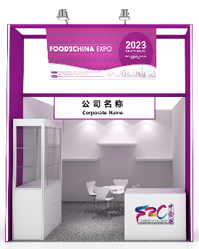 | Shell Scheme Panel, Carpet, Cleaning; Decorative pillar with lights inserted*2; Upper Fascia Board with Pavilion name; Fascia Board with Name + Logo; Lockable Glass Showcase*1; Reception Counter with the logo*1; Chairs*4; Long-arm Spotlight*4; Wooden Shelves*3; White Round Table*1; 5A/220V Socket*1; Waste Bin*1 | USD2880/9sqm
Shell Scheme B  (For Wine and Spirits Pavilion) | 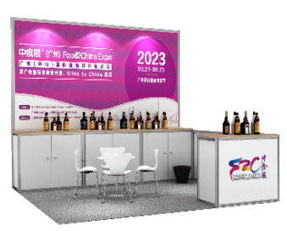 | Signboard with name, Lighting, Carpet; Reception Counter with logo*1; Chairs*4; Round Table*1; 5A/220V Socket*1; Waste Bin*1; Ice bucket*1; Spittoon*1; Wine glasses*6
Raw Space | 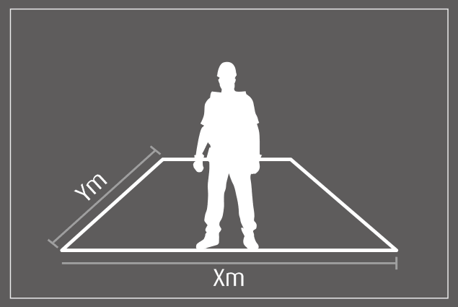 | Min.36sqm: exhibit space only, excluding any equipment, exhibitor should pay electricity and the administrative fee to the exhibition center directly. | USD250/sqm
* Booth equipment is for reference only, and the final exhibition equipment is subject to the organizer's on-site provision.

2. Please reserve square meters in (Imported Food or Wine and Spirits) pavilion,
3. Total participation Fee: USD

Once you submit this application form to the organizer, your participation as an exhibitor at FOOD2CHINA EXPO 2023 will be
confirmed. You will receive an official invoice from the organizer in a separate document. Please complete the payment before
the due day according to the invoice.

Company Name: WorldEx-SingEx Exhibitions (Guangzhou) Company Name:
Co., Ltd.
Signature: Signature:

